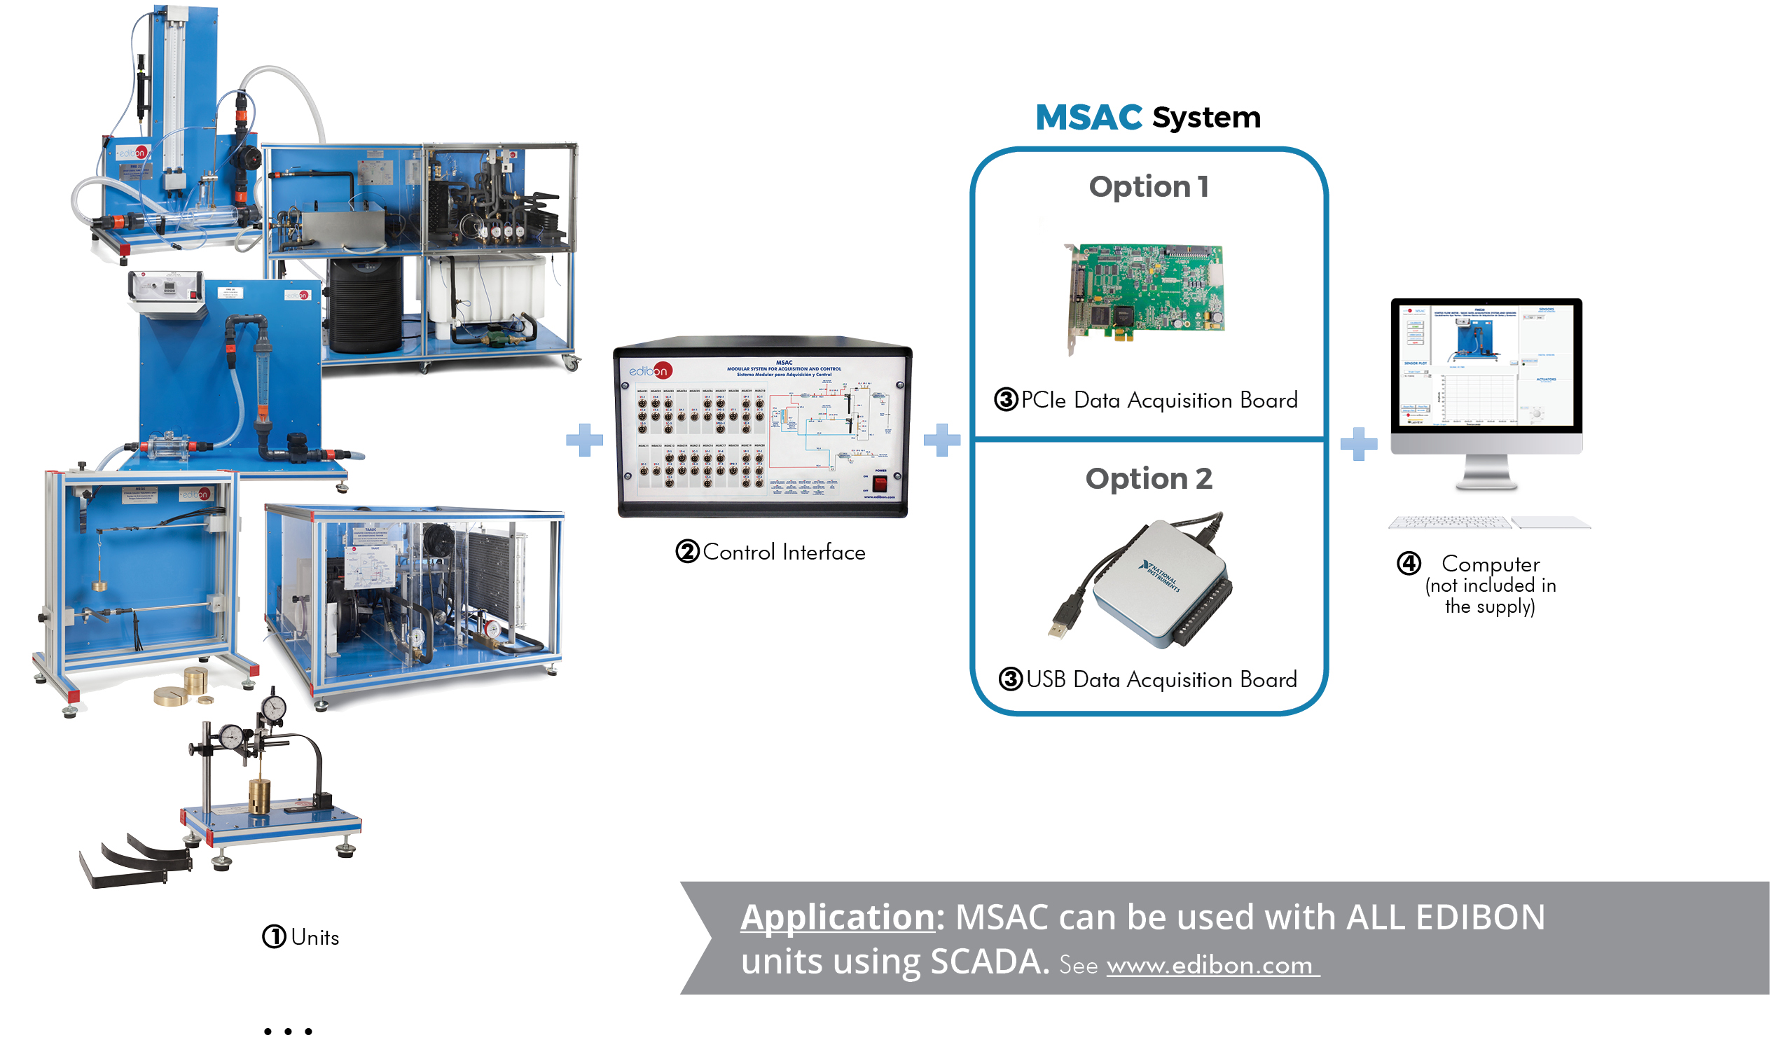

Key features:

- Advanced Real-Time Acquisition and Control System.
- Open Control + Multicontrol + Real-Time Control.
LabVIEW.
- Specialized EDIBON Control Software based on
- National Instruments Data Acquisition board.
- Calibration exercises, which are included, teach the user how to calibrate a sensor and the importance of checking the accuracy of the sensors before taking measurements.
- Projector and/or electronic whiteboard compatibility allows the unit to be explained and demonstrated to an entire class at one time.
- Capable of doing applied research, real industrial simulation, training courses, etc.
- Remote operation and control by the user and remote control for EDIBON technical support, are always included.
- Totally safe, utilizing 4 safety systems (Mechanical, Electrical, Electronic & Software).
- Designed and manufactured under several quality standards.
- ICAI software to create, edit and carry out practical exercises, tests, exams, calculations, etc. Apart from monitoring user’s knowledge and progress reached.
- This unit has been designed for future expansion and integration. A common expansion is the EDIBON Scada-Net (ESN) System which enables multiple students to simultaneously operate many units in a network.

ISO 9001: Quality Management (for Design, Manufacturing, Commercialization and After-sales service)
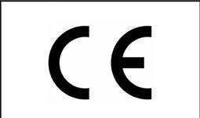

European Union Certificate
(total safety)

Certificates ISO 14001 and ECO- Management and Audit Scheme (environmental management)
1
“Worlddidac Quality Charter” and Platinum Member of Worlddidac

INTRODUCTION

The Modular System for Acquisition and Control consists of a housing or rack in which various electronic cards are connected: communication, measurement, switching, etc. This Modular System is designed for the consumer to make their own combinations and obtain something unique that meets their needs.

GENERAL DESCRIPTION

EDIBON tries to meet the academic demands for teaching and learning in an easy and practical way.
With the Modular System for Acquisition and Control, “MSAC”, students carry out experiments that clearly show them the laws of Hydraulics, Newton´s laws, the principle of conservation of energy, etc. and they gain a valuable experience in the use of instrumentation and tools, in a natural, pleasant and uncomplicated way.
“MSAC” is composed of a control box and several Sensor Modules. This allows the users to set up their own acquisition and control system. Besides, the user has the possibility to purchase more sensor modules or change the version of the Control Interface later if necessary.
The control box is available in two formats depending on the unit and the number of sensors to be measured at the same time. The PCIe Control Interface version is used to measure a wide range of sensors. Signals from sixteen sensors can be acquired at the same time. In contrast, the USB Control Interface version provides a plug and play environment. It supports an acquisition of eight sensors simultaneously.
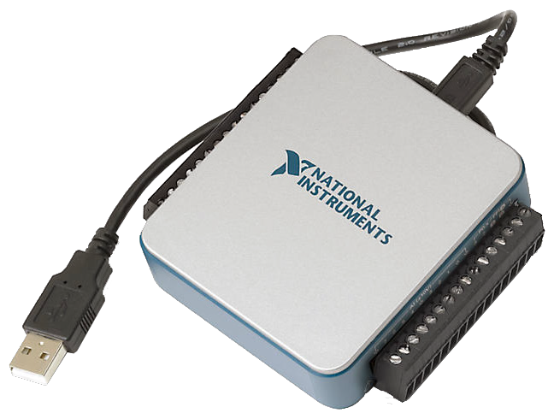
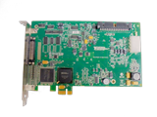

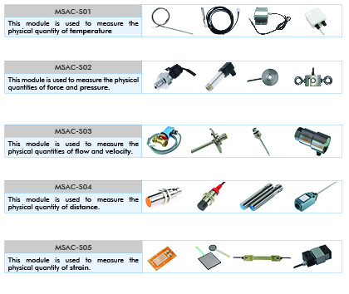
The “MSAC” has different types of sensor modules depending on the units and field of study. These modules do not belong to a specific unit, that is to say, they can be exchanged and used with several units:

GENERAL DESCRIPTION

The “MSAC” includes actuator modules depending on the element to be controlled. The actuator modules can be exchanged and used with several units, just like the sensor modules:
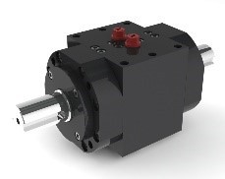

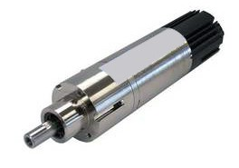

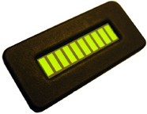

MSAC-A01
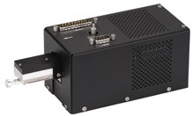

This module is used to control the velocity
and position of an electric motor.

MSAC-A02

This module is used to control actuators, such as relays for valves and pumps.

MSAC-A03
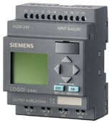

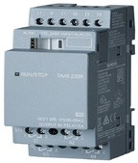

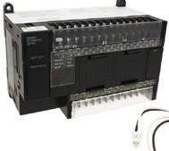

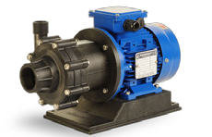

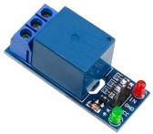

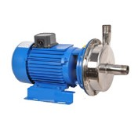

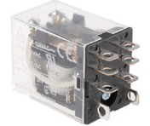

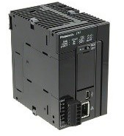

This module is used to control mechanical elements that require a Programmable Logic Controller (PLC).

The following picture shows the included in the MSAC Workstation:

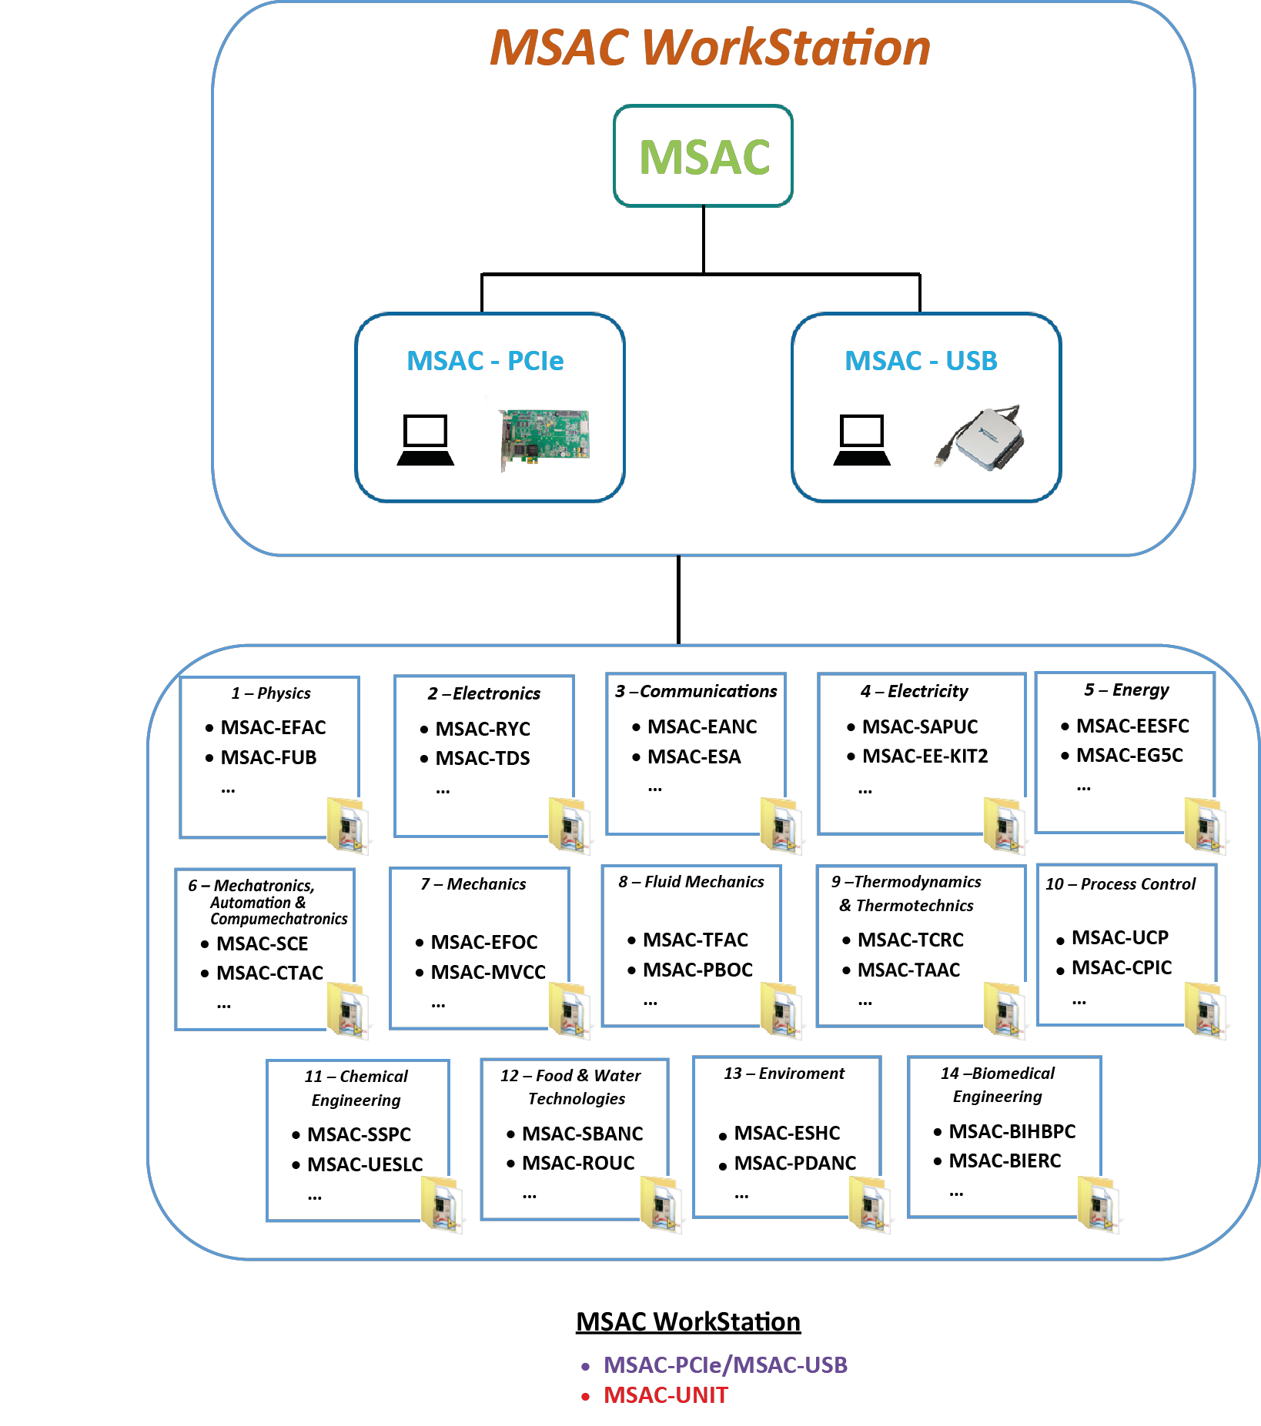

GENERAL DESCRIPTION
GENERAL DESCRIPTION
GENERAL DESCRIPTION

The following picture shows a Laboratory incorporating the ICAI Software System in several Workstations.

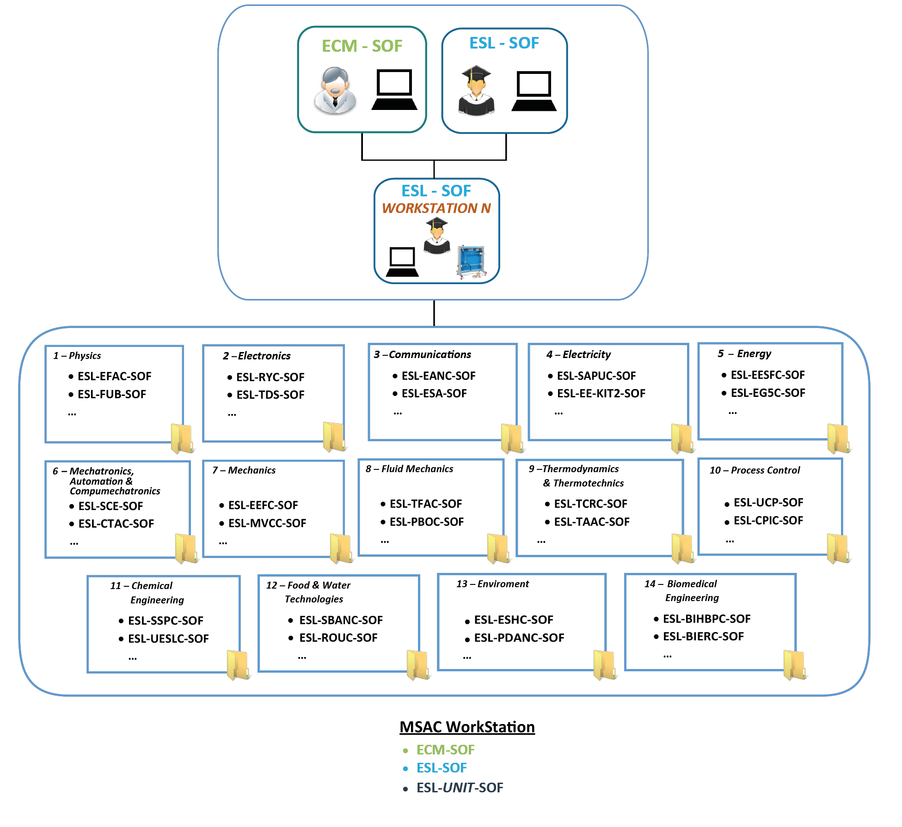

TECHNICAL SPECIFICATIONS

1. Units.
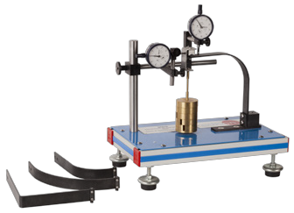

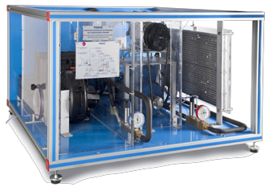

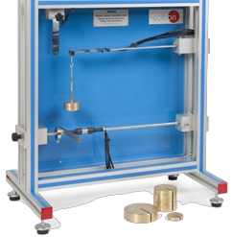

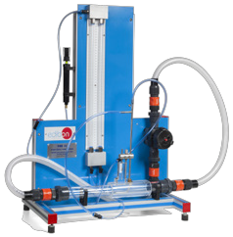

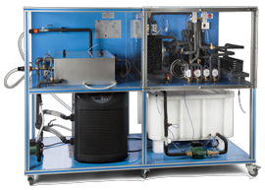

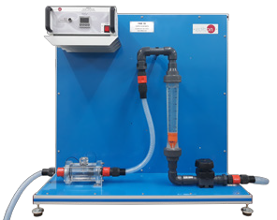

Bench-top unit.
Anodized aluminum frame and panels made of painted steel. Main metallic elements made of stainless steel.
Diagram in the front panel with distribution of the elements similar to the real one.

2. MSAC/CIB. Control Interface Box.
Control interface box is part of the MSAC System.
All sensors, with their respective signals, are properly manipulated from -10V to +10V computer output. Sensors connectors in the interface have different pines numbers (from 2 to 16), to avoid connection errors. Single cable between the control interface box and computer.
The unit control elements are permanently computer controlled, without necessity of changes or connections during the whole process test procedure.
Simultaneous visualization in the computer of all parameters involved in the process.
Real time curves representation about system responses. Storage of all the process data and results in a file. Graphic representation, in real time, of all the process/system responses. All the actuators’ values can be changed at any time from the keyboard allowing the analysis about curves and responses of the whole process.
All the actuators and sensors values and their responses are displayed on only one screen in the computer.
Shield and filtered signals to avoid external interferences. Real time computer control with flexibility of modifications from the computer keyboard of the parameters, at any moment during the process.
Real time computer control for pumps, compressors, heating elements, control valves, etc.
Real time computer control for parameters involved in the process simultaneously. Open control allowing modifications, at any moment and in real time, of parameters involved in the process simultaneously.
Three safety levels, one mechanical in the unit, another electronic in the control interface and the third one in the control software.

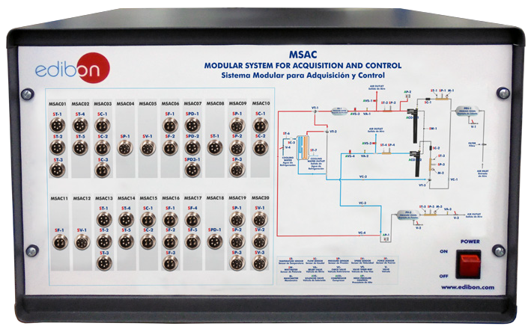

3. DAB. Data Acquisition Board.
The Data Acquisition board is part of the MSAC system. Two version of DAB are available to use:
- PCIe Data Acquisition Board:
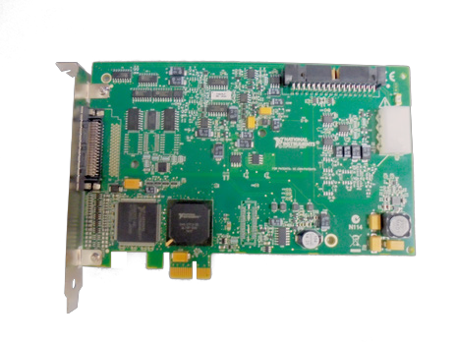
PCI Express Data acquisition board (National Instruments) to be placed in a computer slot. Bus PCI Express.
Analog input: Number of channels= 16 single-ended or 8 differential. Resolution=16 bits,
1 in 65536. Sampling rate up to: 250 KS/s (kilo samples per second). Input range (V) =
±10 V. Data transfers=DMA, interrupts, programmed I/0. DMA channels=6.
Analog output: Number of channels=2. Resolution=16 bits, 1 in 65536. Maximum output rate up to: 900 KS/s. Output range (V) =±10 V. Data transfers=DMA, interrupts, programmed I/0.
Digital Input/Output: Number of channels=24 inputs/outputs. D0 or DI Sample Clock frequency: 0 to 100 MHz. Timing: Number of Counter/timers=4. Resolution: Counter/ timers: 32 bits.

TECHNICAL SPECIFICATIONS

- USB Data Acquisition Board:
National Instruments High Speed Multifunction Data Acquisition Board (20kS/s).
Analog input: Number of channels= 8 single-ended or 8 differential. Resolution=14 bits, 1 in
16384. Sampling rate up to: 10 KS/s (kilo samples per second). Input range (V) = ±10 V. Analog output: Number of channels=2. Resolution=14 bits, 1 in 16384. Maximum output
rate up to: 5 KS/s. Output range (V) =±10 V.
Digital Input/Output: Number of channels=24 inputs/outputs. D0 or DI Sample Clock frequency: 0 to 100 MHz. Timing: Number of Counter/timers=1. Resolution: Timer 32 bits.
Signal Streaming technology through USB to ensure high speed and bidirectional data transfer. USB compatibility: USB2.0 Hi Speed (480Mbits/s) or full speed.
Truly Plug & Play: the PC will automatically detect the new device and install the software.

4. MSAC/CCSOF. Computer Control + Data Acquisition.
The two software are part of the MSAC system. Compatible with actual Windows operating systems.
Graphic and intuitive simulation of the process in screen. Compatible with the industry standards. Registration and visualization of all process variables in an automatic and simultaneous way.
Flexible, open and multicontrol software, developed with actual windows graphic systems, acting simultaneously on all process parameters. Management, processing, comparison and storage of data. Sampling velocity up to 250 KS/s (kilo samples per second).
It allows the registration of the alarms state and the graphic representation in real time.
Comparative analysis of the obtained data, after the process and modification of the conditions during the process.
Open software, allowing the teacher to modify texts, instructions. Teacher’s and student’s passwords to facilitate the teacher’s control on the student, and allowing the access to different work levels.
This unit allows the 30 students of the classroom to visualize simultaneously all the results and the manipulation of the unit, during the process, by using a projector or an electronic whiteboard.

5. Cables and Accessories, for normal operation.

6. Manuals: This unit is supplied with 8 manuals: Required Services, Assembly and Installation, Interface and Control Software, Starting- up, Safety, Maintenance, Calibration & Practices Manuals.

EDIBON UNITS APPLICATIONS

The Modular System for Acquisition and Control, “MSAC”, can be used with any EDIBON units from the following areas:

1.- PHYSICS
2.- ELECTRONICS
3.- COMMUNICATIONS
4.- ELECTRICITY
5.- ENERGY
6.- MECHATRONICS, AUTOMATION & COMPUMECHATRONICS
7.- MECHANICS
8.- FLUID MECHANICS
9.- THERMODYNAMICS & THERMOTECHNICS
10.- PROCESS CONTROL
11.- CHEMICAL ENGINEERING
12.- FOOD & WATER TECHNOLOGIES
13.- ENVIRONMENT
14.- BIOMEDICAL ENGINEERING

EXERCISES AND PRACTICAL POSSIBILITIES

The exercises and practical possibilities of this expansion will be those corresponding to each EDIBON equipment supplied. In this way it will be possible to practice all the areas.

REQUIRED SERVICES

- Electrical supply: single-phase 200 VAC – 240 VAC/50 Hz or 110 VAC – 127 VAC/60 Hz.
- Computer.

DIMENSIONS AND WEIGHTS

MSAC:
Control-Interface Box:
-Dimensions: 490 x 330 x 310 mm approx. (19.29 x 12.99 x 12.20 inches approx.).
-Weight: 10 kg approx.
(22 pounds approx.).
SOFTWARE MAIN SCREENS
Main screen

II I

IV

V

III

I Main software operation possibilities.
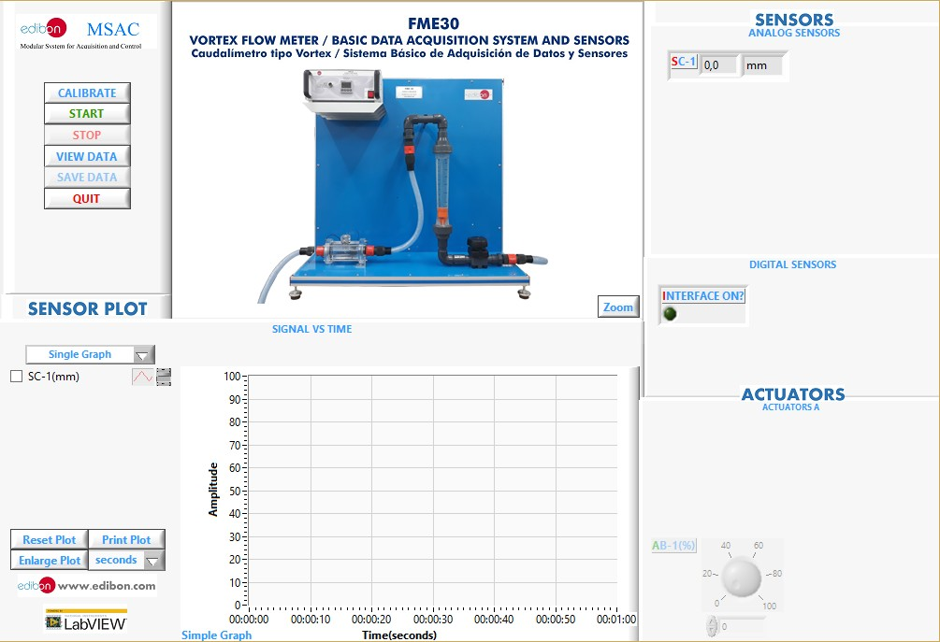

II Sensors displays, real time values, and extra output parameters.

III Actuators controls.
IV Channel selection and other plot parameters.
V Real time graphics displays.

Software for Sensors Calibration
Example of screens
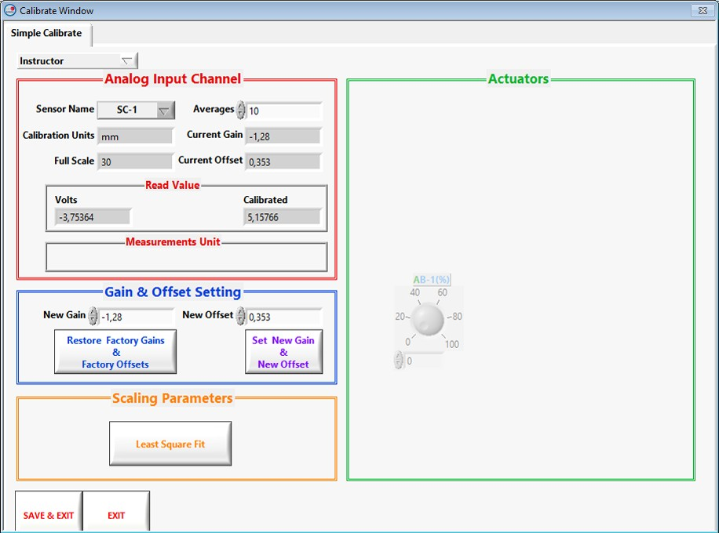

The teacher and the students can calibrate the unit with a password provided by EDIBON. The teacher can restore the factory calibration any time.

SOME REAL RESULTS OBTAINED WITH THIS EXPANSION

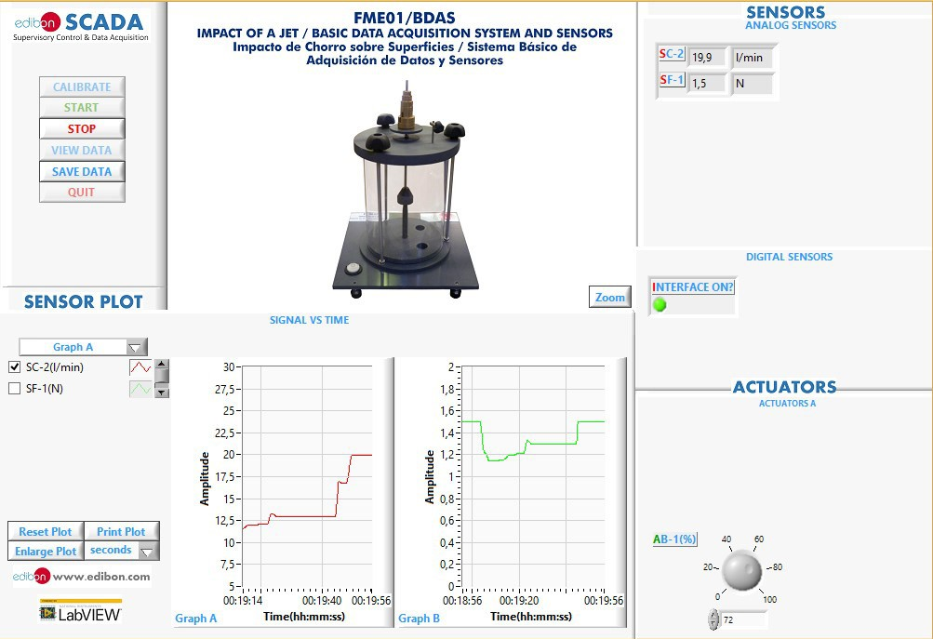

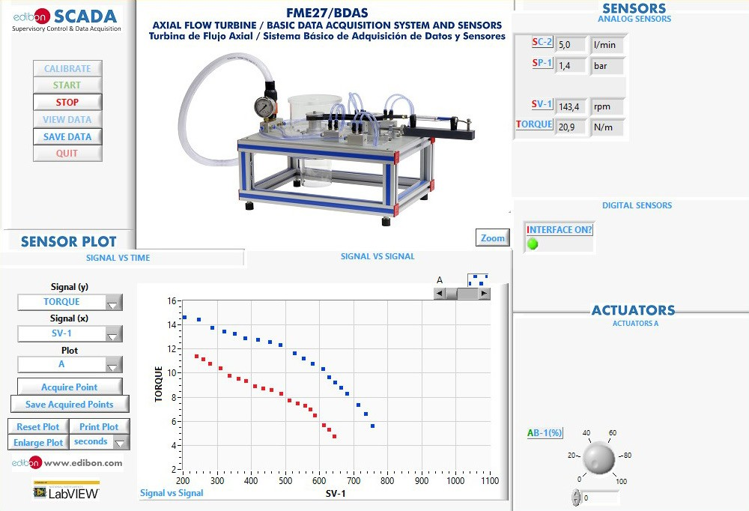

SOME REAL RESULTS OBTAINED WITH THIS EXPANSION

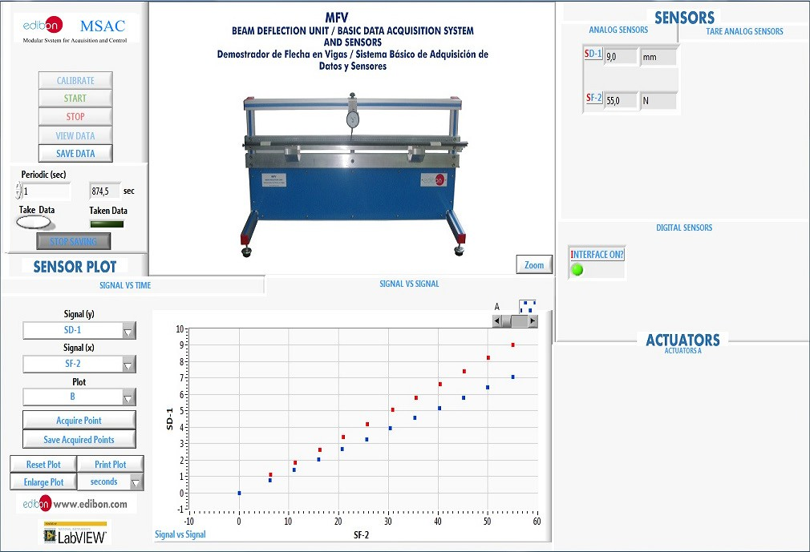

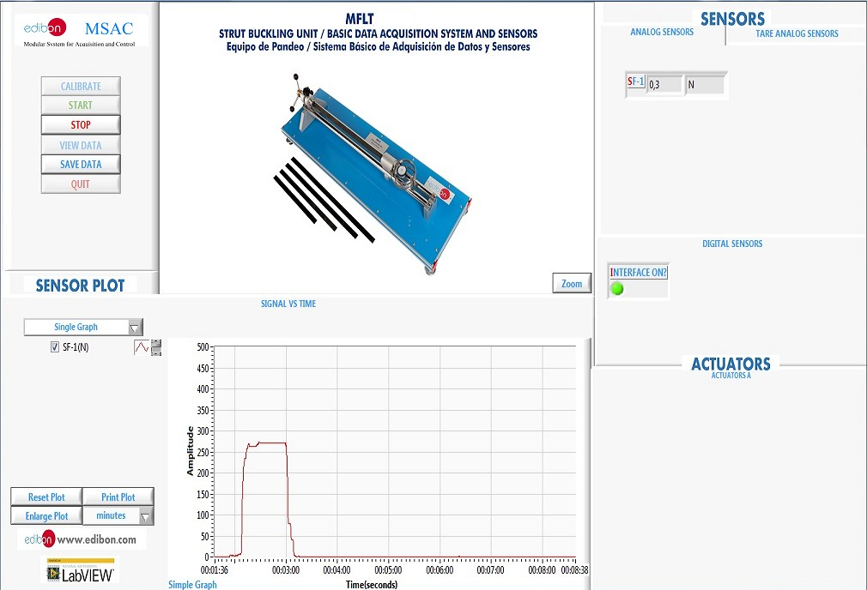

SOME REAL RESULTS OBTAINED WITH THIS EXPANSION

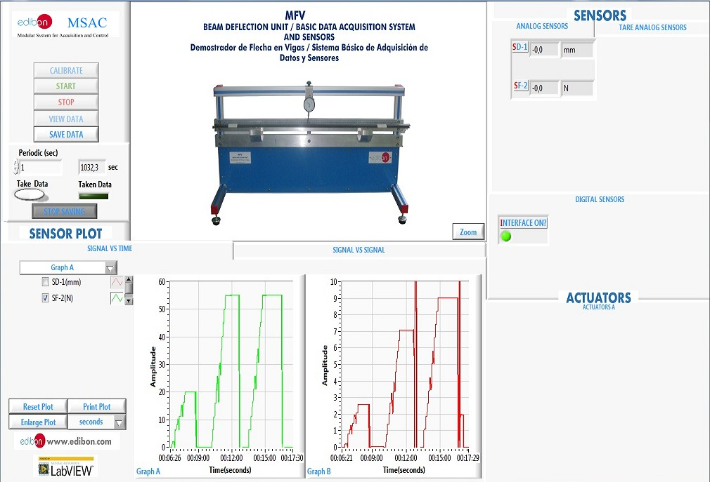

C/ Julio Cervera, 10-12-14. Móstoles Tecnológico.
28935 MÓSTOLES. (Madrid). ESPAÑA - SPAIN. Tel.: 34-91-6199363 Fax: 34-91-6198647
E-mail: edibon@edibon.com Web: www.edibon.com

Edition: ED01/20

Date
/2020

11

